Project Report #1 – Titanic Training Data Mitchell Sydlowski

**Figure 1** below displays the number of passengers aboard the Titanic that survived or perished during the crash. Once split into these two categories, the passengers were divided into three sub-categories based on their class abord the ship, 1st, 2nd, or 3rd.

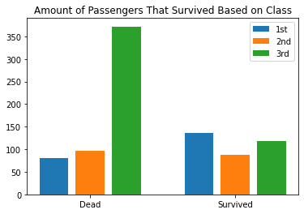

**Figure 1:** Fate of Passengers Aboard the Titanic Based on Class

Most 3rd class passengers perished, about half of the 2nd class passengers perished, and more 1st class passengers survived than those that died. This allows for the assumption that higher class passengers were made a priority when debearding the boat.

The Titanic stopped at three different ports before embarking, Southampton, Queenstown, and Cherbourg. **Figure 2** displays the percentage of passengers that boarded at each port.

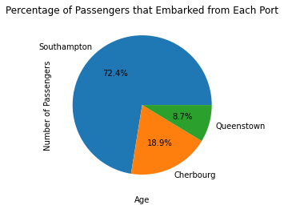

**Figure 2:** Percentage of Titanic Passengers that Boarded at Each Port

**Figure 3** displays a scatter plot between ticket fare and passenger class. The linear regression line displays a negative correlation of –0.55. Ticket prices typically increased as passenger class increased.

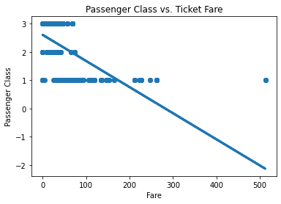

**Figure 3:** Passenger Class vs. Passenger Ticket Fare

**Figure 4** displays the total number of passengers that either survived or perished as a result of the crash.

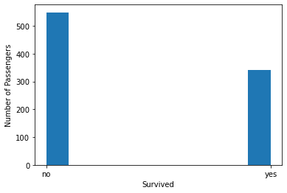

**Figure 4:** Number of Passengers that Survived or Perished

**Figure 5** shows a contingency table for the gender of each passenger and their boarding dock. Average fares for each boarding location are as follows: Southampton: $27.08 Queenstown: $13.28 Cherbourg: $59.95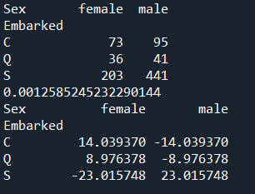

**Figure 5:** Contingency Table